How to connect your google sign-in

You open your browser to login to Classlink and you get this screen. Click on the “Home” icon to take you to the URL <http://launchpad.classlink.com/lancsd>

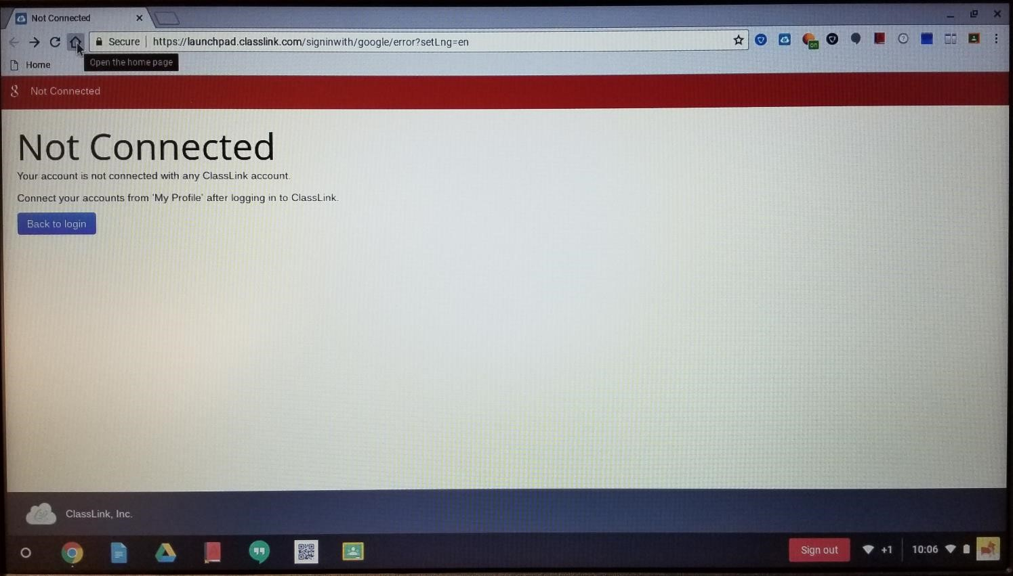

You’ll be redirected to Classlink’s login page. Click “Sign In With AD.”

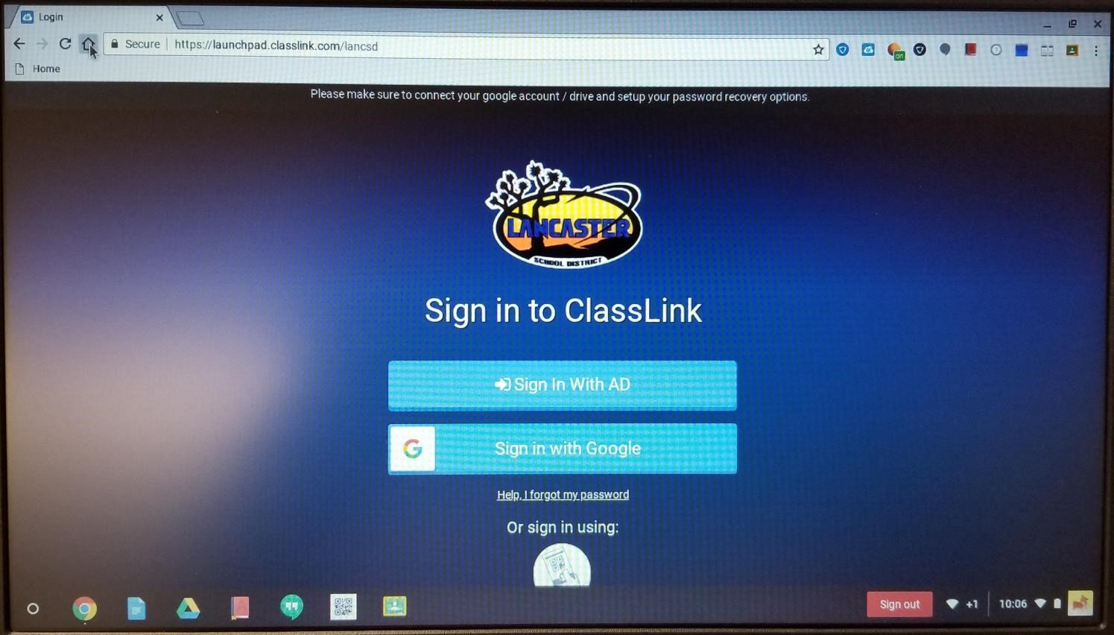

You may be prompted to confirm your identity. Enter your username@stu.lancsd.org/password (e.g. milenac9805@stu.lancsd.org/\*\*\*\*\*\*\*\*\*\*\*\*) and click “Sign In.”

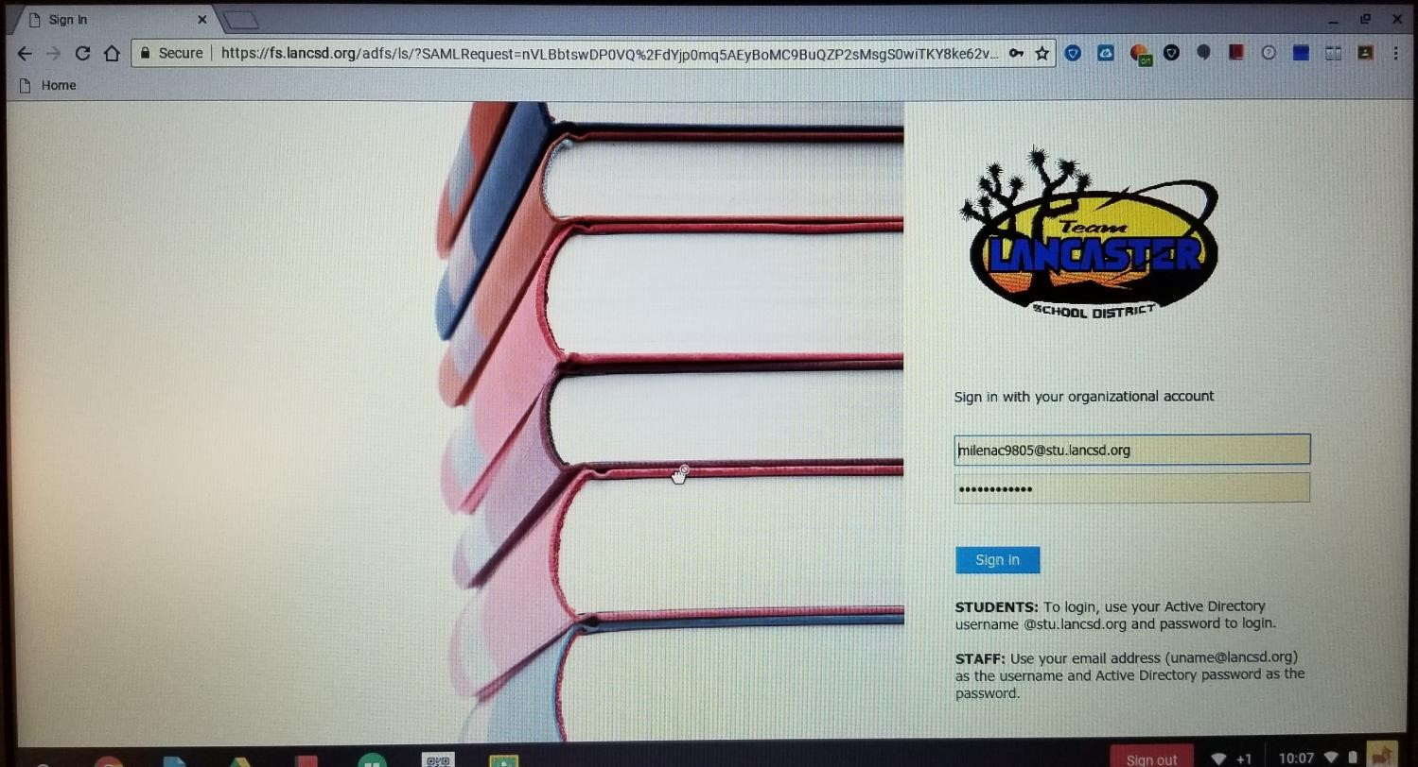

Your Classlink page should load as expected.

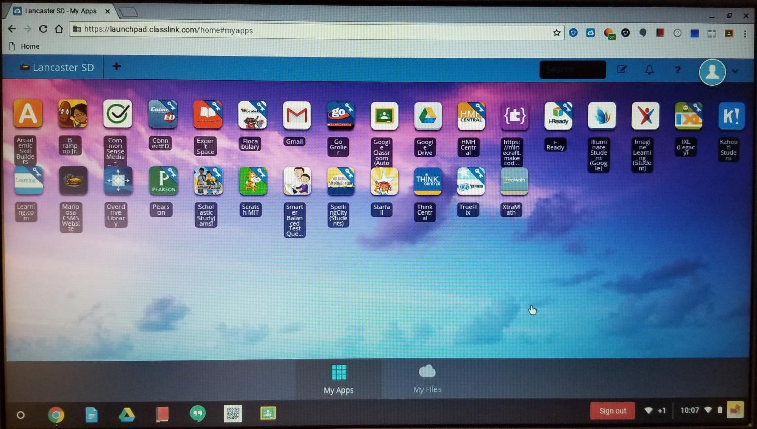

Click on your Classlink Profile Icon at the upper right of the webpage.

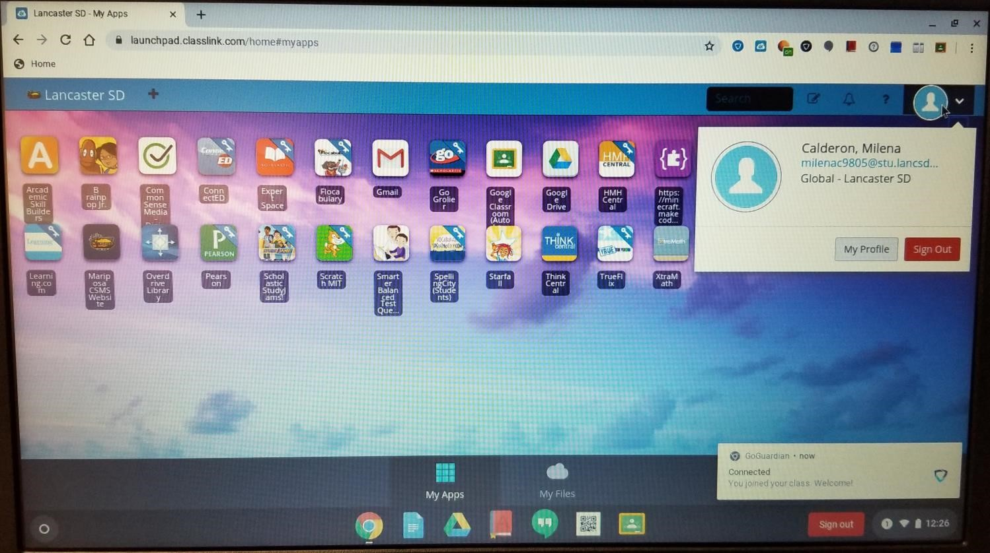

Click on “My Profile.”

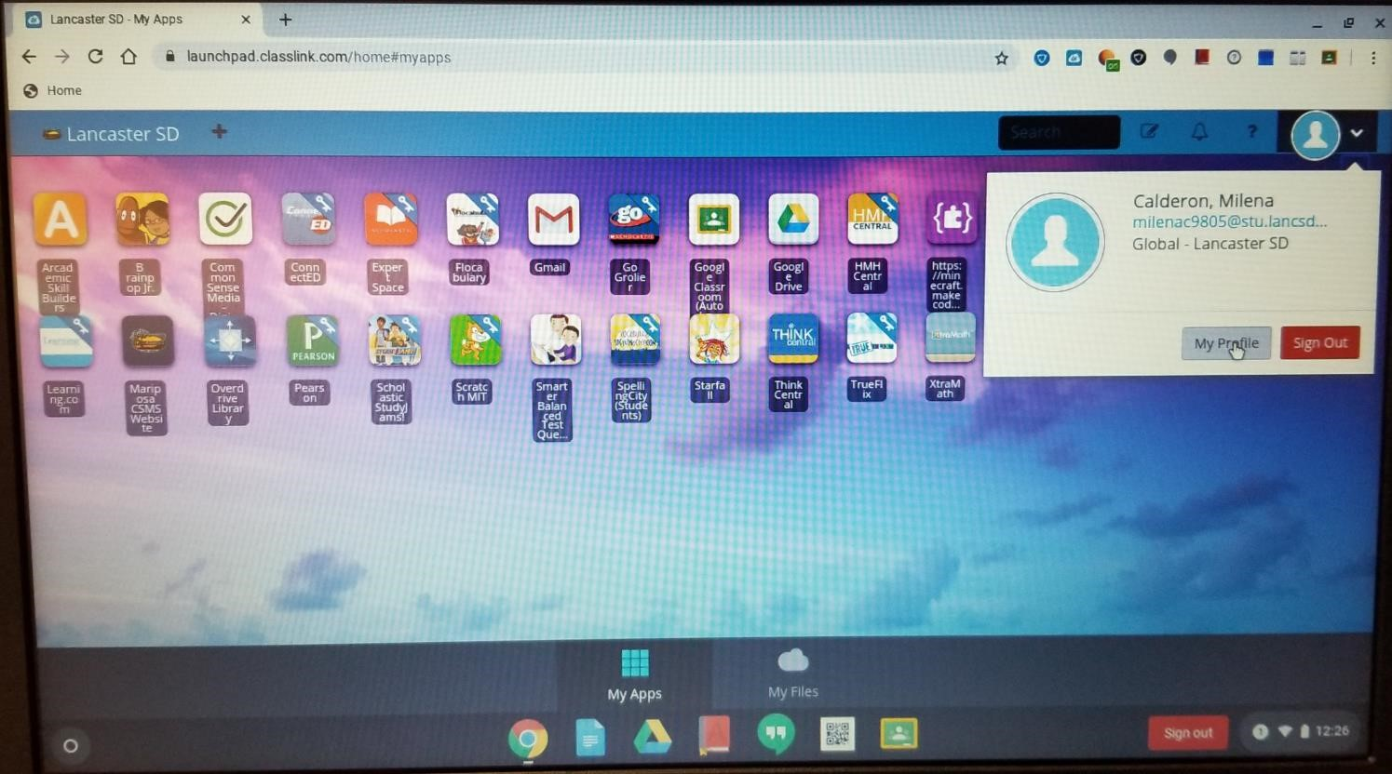

A new window should appear, click on “Sign-In Options” at the left hand side.

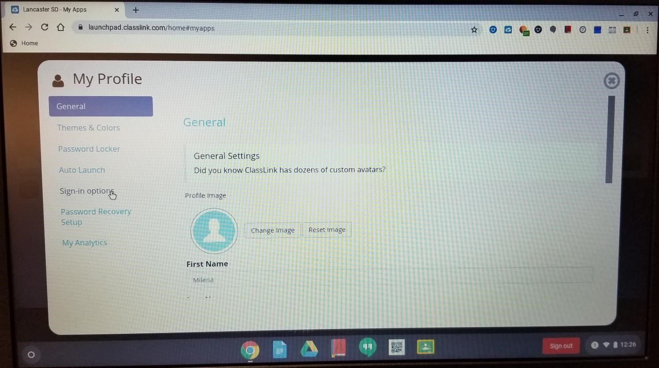

Click on “Connect” to the right of “Google Account”

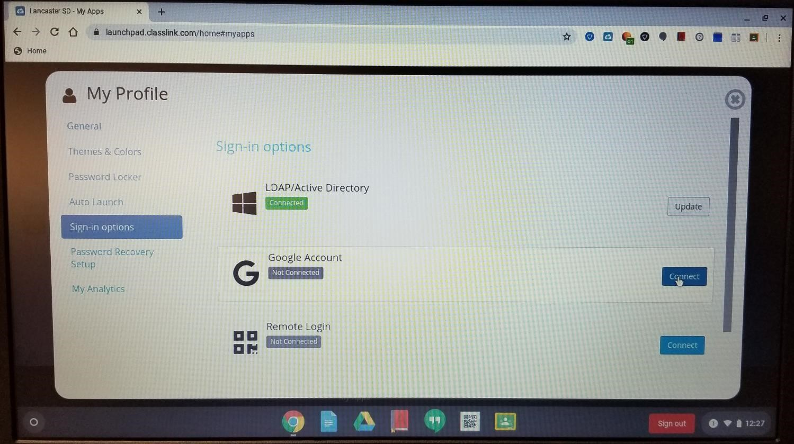

Once Classlink has connected to Google, a confirmation page will appear.

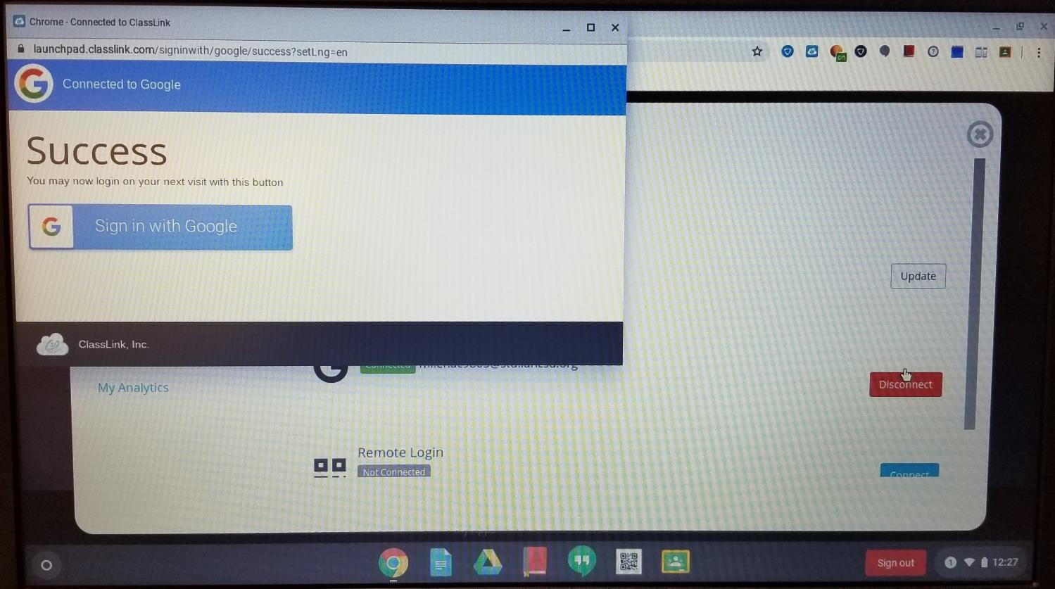

Now, the next time you log into your Chromebook, it should automatically load your Classlink page without having to login with extra steps.